**TOURS AND TRAVELS WEBSITE**

**(TRAVEL MINDS)**

Submitted in partial fulfillment of requirements for the subject of

**Internet Programming Lab**

**By**

Dhanashri Shinde

Roll No: 62

Siddhesh Sawant

Roll No: 58

Mohit Surve

Roll No: 67

**Under the supervision of**

Prof. R. V. Sangle



**DEPARTMENT OF INFORMATION TECHNOLOGY**

**KONKAN GYANPEETH COLLEGE OF ENGINEERING KARJAT- 410201**

**2020-2021**

**Certificate**

This is to certify the project entitled **Tours and Travels Website (Travel Minds)** is a bonafide work of **Dhanashri Shinde** (Roll No: 62), **Siddhesh** Sawant (Roll No: 58), **Mohit Surve** (Roll No: 67)submitted to the **Department of Information Technology** in partial fulfillment of the requirement for the subject of **Internet Programming Lab.**

|  |  |
| --- | --- |
| Supervisor Guide | Head of Department |
| **Prof. R. V. Sangle** | **Prof. J. P. Patil** |
| Dept. of Information Technology | Dept. of Information Technology |

**Project Report Approval**

This project report entitled **TOURS AND TRAVELS WEBSITE (TRAVEL MINDS)**, by **Dhanashri Shinde** (Roll no: - 62), **Siddhesh Sawant** (Roll no: - 58), **Mohit Surve** (Roll no: - 67) is approved for the partial fulfilment of the requirement for the subject of internet programming lab.

**EXAMINERS**

**1……………………………….…………….**

**2……………………………………………..**

**Date:**

**Place:**

**Declaration**

We declare that this written submission represents our ideas in our own words and where other ideas or words have been included. We have adequately cited and referenced the original sources. We also declare that we have adhered to all principles of academic honesty and integrity and have not misrepresented or fabricated or falsified any idea/data/fact /source in our submission. We understand that any violation of the above will be cause for disciplinary action by the institute and can also evoke penal action from the source which have thus nor been properly cited or from whom proper permission has not been taken when needed.

Signature

Dhanashri Shinde

(Roll No: - 62)

Signature

Siddhesh Sawant

(Roll No: - 58)

Signature

Mohit Surve

(Roll No: - 67)

**Abstract**

The purpose of the Tours and Travels Website (Travel Minds) is to automate the existing manual system with the help of computerized equipment and full-fledged computer software, fulfilling their requirements, so that their valuable data/information can be stored for a longer period with easy accessing and manipulation of the same. The required software and hardware are easily available and easy to work with.

Tours and Travels Website (Travel Minds) as described above, can lead to an error-free secure, reliable and fast management system. It can assist the user to concentrate on their other activities rather than concentrate on record-keeping. Thus, it will help the organization in better utilization of resources. The organization can maintain computerized records without redundant entries. This means that one need not be distracted by information that is not relevant while being able to reach the information.

The aim is to automate its existing manual system with the help of computerized equipment and full-fledged computer software, fulfilling their requirements, so that their valuable data\information can be stored for a longer period with easy accessing and manipulation of the same. Basically, the project describes how to manage for good performance and better services for the clients.

**Acknowledgment**

We would like to express our special thanks of gratitude to our guide Prof. R. V. Sangle for her support in building synopsis as well as our sir Prof. J. P. Patil (Head of Department Information Technology) who gave us the golden opportunity to do this wonderful project on the topic Tours and Travels Website (Travel Minds) which also helped us in doing a lot of research and we came to know about so many new things we are really thankful to them secondly we would also like to thank our parents and friends who helped us a lot in finalizing this project within the limited time frame.

Contents

|  |  |  |  |  |
| --- | --- | --- | --- | --- |
| Certificate 1 | | | | |
| Project Report Approval 2 | | | | |
| Declaration 3 | | | | |
| Abstract 4 | | | | |
| Acknowledgments 5 | | | | |
| 1. | Introduction | | 10 |  |
|  | 1.1 | Introduction | 10 |  |
|  | 1.2 | Objectives | 11 |  |
|  | 1.3 | Purpose, scope, and application | 11 |  |
|  | 1.3.1. Purpose  1.3.2. Scope  1.3.3 Applicability | | 11 |  |
|  | 12 |  |
|  | 12 |  |
| 2. | Literature survey | | 14 |  |
| 3. | Requirements and analysis | | 16 |  |
|  | 3.1 | Problem definition | 17 |  |
|  | 3.2 | Planning and scheduling | 17 |  |
|  | 3.3 | Software and hardware requirements | 18 |  |
| 4. | System design | | 19 |  |
|  | 4.1.1 Architecture Diagram | | 19 |  |
| 5. | Implementations | | 21 |  |
|  | 5.1 | Software implementation | 21 |  |
| 6. | Conclusions | |  |  |
|  | 6.1 | Conclusion | 40 |  |
|  | 6.2  6.3 | Limitations of the system  Future scope | 40  41 |  |
|  |  |  |  |  |
| Bibliography 42 | | | | |

**CHAPTER 1**

**Introduction**

* 1. **Introduction:**

A travel website is a [website](https://en.wikipedia.org/wiki/Website) that is dedicated to [travel](https://en.wikipedia.org/wiki/Travel). The site may be focused on travel [reviews](https://en.wikipedia.org/wiki/Review), trip fares, or a combination of both. Over 1.5 billion people book travel per year, 70% of which is done online.

Categories of travel websites include:

Travelogues/Blogs - See [Travel literature #Travel blogs](https://en.wikipedia.org/wiki/Travel_literature#Travel_blogs).

Review websites - Some examples of websites that use a combination of travel reviews and the booking of travel are [TripAdvisor](https://en.wikipedia.org/wiki/TripAdvisor), [Priceline.com](https://en.wikipedia.org/wiki/Priceline.com), Liberty Holidays, and [Expedia](https://en.wikipedia.org/wiki/Expedia).

Service providers - Individual [airlines](https://en.wikipedia.org/wiki/Airline), [hotels](https://en.wikipedia.org/wiki/Hotel), [bed and breakfasts](https://en.wikipedia.org/wiki/Bed_and_breakfast), [cruise lines](https://en.wikipedia.org/wiki/Cruise_line), [automobile rental](https://en.wikipedia.org/wiki/Automobile_rental) companies, and other travel-related service providers often maintain their own web sites providing retail sales. Many with complex offerings include some sort of [search engine technology](https://en.wikipedia.org/wiki/Search_engine_technology) to look for bookings within a certain timeframe, service class, geographic location, or price range.

Online travel agencies - See [travel agency](https://en.wikipedia.org/wiki/Travel_agency).

Fare aggregators and metasearch engines - [Metasearch engines](https://en.wikipedia.org/wiki/Metasearch_engine) conduct searches across multiple independent [search engines](https://en.wikipedia.org/wiki/Search_engine). Metasearch engines often make use of "[screen scraping](https://en.wikipedia.org/wiki/Screen_scraping)" to get live availability of flights. Screen scraping is a way of crawling through the airline websites, getting content from those sites by extracting data from the same HTML feed used by consumers for browsing (rather than using a [Semantic Web](https://en.wikipedia.org/wiki/Semantic_Web) or database feed designed to be machine-readable). Metasearch engines usually process incoming data to eliminate duplicate entries, but may not expose "advanced search" options in the underlying databases (because not all databases support the same options).

Blogs/News sites on current travel discounts - Travel bargain websites collect and publish bargain rates by advising consumers where to find them online (sometimes but not always through a direct link). Rather than providing detailed search tools, these sites generally focus on offering advertised specials, such as last-minute sales from travel suppliers eager to deplete unused inventory; therefore, these sites often work best for consumers who are flexible about destinations and other key itinerary components.

Travel and tourism guides - Many websites take the form of a digital version of a traditional [guide book](https://en.wikipedia.org/wiki/Guide_book), aiming to provide advice on which destinations, attractions,

accommodations, and so on, are worth a visit and providing information on how to access them. Most states, provinces and countries have their own [convention and visitor bureaus](https://en.wikipedia.org/wiki/Convention_and_visitor_bureau), which usually sponsor a website dedicated to promoting [tourism](https://en.wikipedia.org/wiki/Tourism) in their respective regions. Cities that rely on tourism also operate websites promoting their destinations, such as [VEGAS.com](https://en.wikipedia.org/wiki/VEGAS.com) for [Las Vegas](https://en.wikipedia.org/wiki/Las_Vegas).

Social travel website - A social travel website is a type of travel website that will look at where the user is going and pair them with other places they want to go based on where other people have gone.[[2]](https://en.wikipedia.org/wiki/Travel_website#cite_note-2)

Homestays - There are several travel websites that specialize in organizing [homestays](https://en.wikipedia.org/wiki/Homestay). These include: [9flats](https://en.wikipedia.org/wiki/9flats), [Airbnb](https://en.wikipedia.org/wiki/Airbnb), [Be Welcome](https://en.wikipedia.org/wiki/BeWelcome), Couch Surfing, [Friendship Force International](https://en.wikipedia.org/wiki/Friendship_Force_International), [HomeExchange.com](https://en.wikipedia.org/wiki/HomeExchange.com), [Hospitality Club](https://en.wikipedia.org/wiki/Hospitality_Club), Interval, [OYO Rooms](https://en.wikipedia.org/wiki/OYO_Rooms), [Passport Servo](https://en.wikipedia.org/wiki/Pasporta_Servo), Serves, Third Home, [Tripping.com](https://en.wikipedia.org/wiki/Tripping.com), [Warm Showers](https://en.wikipedia.org/wiki/Warm_Showers), Workaday, and [WWOOF](https://en.wikipedia.org/wiki/WWOOF).

* 1. **Objectives:**

1. Provide a high standard of services suitable for individuals seeking relaxing, comfortable and memorable experiences in the hospitality and tourism industry.
2. Provide the tourist market with the quality personal required by the tourism industry.
3. Produce expeditions and memories that would satisfy each and every single of the customers.
4. Evaluate current cultural, economic, and social issues affecting the tourism and travel industry.
   1. **Purpose, Scope and Applicability:**
      1. **Purpose:**

We believe that tourism should help improve the satisfaction and experience of tourist. In every way possible, Vacation & Nightlife Planners PR is committed to the realization of this vision as we strive to be recognized by organizations and travellers alike as one of Puerto Rico’s most outstanding centre of tourism planning and tours. We aim to be a recognized and certified program by 2014.

In engaging this vision, the department specifically aims to:

•   Encourage innovation, research, and quality information exchange within the Tourism community and among stakeholders in tourism and allied industries.

•   Foster excellence in all the activities by developing appropriate physical, social and cultural environments, and by fostering a solid partnership with industry and the wider community.

* + 1. **Scope:**

Vacation & Nightlife Planners PR is a provider of competency-based expeditions, multi-theme activities, economical and sustainable tourism projects. In line with transformation in this sector and relevant to those who aim to pursue a budget quality experience in the tourism and allied industries. We actively seek the continual improvement of performance programs and its parts, through sharing of agglomeration of capabilities, knowledge, resources, influences and information within institutional structural and reporting arrangements.

* + 1. **Applicability:**

With the latest communication technology to provide the highest level of services, our computerized online system not only provides up to the last minute “best buy” fares but is also capable of reserving the hotel of your choice world- wide 24 hours, 7 days a week. A solid infrastructure has been built with dedicated and knowledgeable staff to help you get the most of your travel expenditure.

Our inbound division has partnered with local suppliers to ensure the best price and quality of service to our clients

**CHAPTER 2**

**Literature Survey**

Criteria to evaluate the effectiveness of tourism web sites need to be developed for the advancement of the tourism industry. The earliest attempts to measure the effectiveness of web sites in general were purely subjective individual preferences such as “Cool Links”, “Top Lists”, and “Hot Sites” (Ho, 1997). Further efforts have taken the form of many awards that assess the web site's effectiveness using more systematic methods. Examples of such awards are “Soda Awards” (www.soda.co.nz), "Lycos Top 5%" (point.lycos.com/categories), and “Hot 100 sites” (www.hot100.com). The criteria for the awards vary. For example, the Soda award is given to New Zealand sites that show excellence in one or more of the following criteria: content, graphical “out-there-ness”, layout, speed, net-cred (frame use, tables, HTML design), instructiveness, and updates.

**CHAPTER 3**

**Requirements and Analysis**

**3.1 Problem Definition:**

The success model of the e-tourism company could be defined as driven forward by two dominating forces: customer and technology. The customer, who works as the market pull factor and the technology as the push factor, both determine the e-business success. Dynamic packaging reflects the combination of these two factors: delivery of a highly customized product based on advanced information technologies. First section of the thesis gives an overview of the current tourism industry which has been significantly changed due to the emerging information technologies. The changes occurred in the last years are discussed separately for the various suppliers of the travel product. This should better illustrate the specific environment in which they operate as well as the challenges they face. The players taken into consideration include airlines, hotels, cruise lines and car rental companies. The transition from the offline to the online environment contributed in the first stage to the disintermediation process. Later, the need for the organization and integration of the information initiated a return to the reintermediation of the travel products. Online travel agencies, due to the reintermediation, present a new delivery channel for the travel product. Their success depends on a high participation level of the various tourism players. The tourism companies most usually use a portfolio of distribution channels. However, the channels cannot be ad infinitum added as they emerge. The alternative choices will be carefully evaluated by the management to maximize the tangible and intangible benefits as well as to minimize the costs. The conducted analysis takes into consideration three decisions areas: operational, tactical and strategic. Every conducted analysis includes the comparison of three different distribution channels: the traditional agency, the own suppliers web page and the online travel agency. Finally, the cost/benefit analysis will be presented from the customer’s perspective to ensure the comprehensive presentation of Online Travel Agencies (OTA) as a distribution channel, taking into consideration the possible threads and opportunities.

**3.2 Planning and Scheduling:**

**Start Date:** 14/08/2020 **End Date:** 21/08/2020

Schedule wise preparations tools place between the team as the topic was decided which is “Tours and Travels Website”. As the topic was decided, the next step was to give a name; a title. Travel Minds was decided among us which suited the vision and planning behind building this website.

The next step for us was to decide who will be making the specific pages as this will be a team effort.

One member decided to make the Home, Blog and Contact Us pages while the 2nd will do the Flights and Hotels. The 3rd will be playing a vital role in making the packages page and handling the database part.

As per the schedule goes which is from Friday to Friday, everyone performed their particular tasks successfully and completed the webpages at the given time.

**3.3 Software and Hardware Requirements**

* **Hardware Requirements:**

1. Processor (minimum Pentium).
2. Hard Disk.
3. Laptop/Personal Computer.

* **Software Requirements:**

1. Web Technologies: Sublime Text 3.
2. Language: Html, CSS, php, JavaScript.
3. Database: MySQL.
4. Operating System: Windows 10.

**CHAPTER 4**

**System Design**

1. **Architecture Diagram:**

HOME PAGE

PACKAGES

HOTELS

FLIGHTS

CONTACT US

BLOG

SIGN UP

LOG IN

BOOK FLIGHT/HOTEL

DATABASE STORAGE

INFORMATION STORED IN DATABASE

RETREIVAL

PROCESSED AND FURTURE INFORMATION IS GIVEN TO THE CUSTOMER

**CHAPTER 5**

**Implementations**

* 1. **Software Implementation:**

**Home Page Code:**

**<!DOCTYPE html>**

**<head>**

**<meta charset="UTF-8">**

**<meta name="description" content="">**

**<meta http-equiv="X-UA-Compatible" content="IE=edge">**

**<meta name="viewport" content="width=device-width, initial-scale=1, shrink-to-fit=no">**

**<title>Travel Minds | Home</title>**

**<link href="./css/Home.css" rel="stylesheet">**

**<link href="css/responsive/responsive.css" rel="stylesheet">**

**<link rel="stylesheet" href="./css/icomoon.css">**

**</head>**

**<body>**

**<div class="-container">**

**<div class="container">**

**<header>**

**<div id="branding">**

**<a class="branding" href="Home.html"><img src="Logo.png" alt=""></a>**

**</div>**

**<nav>**

**<ul id="buttons">**

**<li class="SignUp"><a href="SignUp and LogIn.html">Sign Up</a></li>**

**<li class="LogIn"><a href="SignUp and LogIn.html">Log In</a></li>**

**</ul>**

**</nav>**

**</header>**

**<section class="Discover">**

**<div class="Cover h-100">**

**<div class="Row h-100 align-items-center justify-content-center">**

**<div class="Col">**

**<div clas="Guide-content">**

**<h2>Discover</h2>**

**<h4>Choose any of the following:</h4>**

**</div>**

**</div>**

**</div>**

**</div>**

**</section>**

**<section class="Category Menu">**

**<div class="Menu">**

**<div class="Row">**

**<div class="Col">**

**<div class="all-categories">**

**<div class="Row">**

**<div class="Col">**

**<div class="single-area-category">**

**<div class="category-content">**

**<img src="./Icons/flight.png" class="imglogo" alt="flight">**

**<a href="travel.html">**

**<h6>Flights</h6>**

**</a>**

**</div>**

**</div>**

**</div>**

**<div class="Col">**

**<div class="single-area-category">**

**<div class="category-content">**

**<img src="./Icons/hotel.png" class="imglogo" alt="hotel">**

**<a href="#">**

**<h6>Hotels</h6>**

**</a>**

**</div>**

**</div>**

**</div>**

**<div class="Col">**

**<div class="single-area-category">**

**<div class="category-content">**

**<img src="./Icons/box.png" class="imglogo" alt="box">**

**<a href="Packages.html">**

**<h6>Packages</h6>**

**</a>**

**</div>**

**</div>**

**</div>**

**<div class="Col">**

**<div class="single-area-category">**

**<div class="category-content">**

**<img src="./Icons/place.png" class="imglogo" alt="place">**

**<a href="Blog.html">**

**<h6>Blog</h6>**

**</a>**

**</div>**

**</div>**

**</div>**

**<div class="Col">**

**<div class="single-area-category">**

**<div class="category-content">**

**<img src="./Icons/place.png" class="imglogo" alt="place">**

**<a href="Contact Us.html">**

**<h6>Contact Us</h6>**

**</a>**

**</div>**

**</div>**

**</div>**

**</div>**

**</div>**

**</div>**

**</div>**

**</div>**

**</section>**

**<div id="fh5co-features">**

**<div class="fh5co-container">**

**<div class="f5hco-features-row">**

**<div class="col-md-4 animate-box">**

**<div class="feature-left">**

**<span class="icon">**

**<i class="icon-hotairballoon"></i>**

**</span>**

**<div class="feature-copy">**

**<h3 class="h3-features">Family Travel</h3>**

**<p class="p-features">Get upto 40% Off on your first Family Travel Wombo Combo. T&C</p>**

**<p><a href="#">Learn More</a></p>**

**</div>**

**</div>**

**</div>**

**<div class="col-md-4 animate-box">**

**<div class="feature-left">**

**<span class="icon">**

**<i class="icon-search"></i>**

**</span>**

**<div class="feature-copy">**

**<h3 class="h3-features">Travel Plans</h3>**

**<p class="p-features">Get upto 20% cashback after your Travel. Best Plans only on Travel Minds. </p>**

**<p><a href="#">Learn More</a></p>**

**</div>**

**</div>**

**</div>**

**<div class="col-md-4 animate-box">**

**<div class="feature-left">**

**<span class="icon">**

**<i class="icon-wallet"></i>**

**</span>**

**<div class="feature-copy">**

**<h3 class="h3-features">Honeymoon</h3>**

**<p class="p-features">Newly Married? Get upto 15% discount on hotels through Travel Minds.</p>**

**<p><a href="#">Learn More</a></p>**

**</div>**

**</div>**

**</div>**

**</div>**

**<div class="f5hco-features-row">**

**<div class="col-md-4 animate-box">**

**<div class="feature-left">**

**<span class="icon">**

**<i class="icon-wine"></i>**

**</span>**

**<div class="feature-copy">**

**<h3 class="h3-features">Business Travel</h3>**

**<p class="p-features">Get the advantage of the best flights experience at 20% discount rate.</p>**

**<p><a href="#">Learn More</a></p>**

**</div>**

**</div>**

**</div>**

**<div class="col-md-4 animate-box">**

**<div class="feature-left">**

**<span class="icon">**

**<i class="icon-genius"></i>**

**</span>**

**<div class="feature-copy">**

**<h3 class="h3-features">Solo Travel</h3>**

**<p class="p-features">Alone? No worries. We have the best plans here at Travel Minds.</p>**

**<p><a href="#">Learn More</a></p>**

**</div>**

**</div>**

**</div>**

**<div class="col-md-4 animate-box">**

**<div class="feature-left">**

**<span class="icon">**

**<i class="icon-chat"></i>**

**</span>**

**<div class="feature-copy">**

**<h3 class="h3-features">Explorer</h3>**

**<p class="p-features">Explore More here at Travel Minds with Open Possiblities of exploring at lower price.</p>**

**<p><a href="#">Learn More</a></p>**

**</div>**

**</div>**

**</div>**

**</div>**

**</div>**

**</div>**

**<!-- fh5co-blog-section -->**

**<div id="fh5co-testimonial">**

**<div class="testimonial-container">**

**<div class="testimonial-row-1 animate-box">**

**<div class="col-md-8 col-md-offset-2 text-center fh5co-heading">**

**<h2 class="h2-testimonial">Happy Clients</h2>**

**</div>**

**</div>**

**<div class="testimonial-row-2">**

**<div class="col-md-4">**

**<div class="box-testimony animate-box">**

**<blockquote>**

**<span class="quote"><span><i class="icon-quotes-right"></i></span></span>**

**<p>&ldquo;"Best site to get best deals on your travel. Well Organised and equipped with the best staff ever. Thank you for making my travel a lot faster and cheaper and safer."&rdquo;</p>**

**</blockquote>**

**<p class="author">Jake Dre, CEO <a href="#" target="_blank">makebelieve.com</a> <span class="subtext">Make Believe Foundation</span></p>**

**</div>**

**</div>**

**<div class="col-md-4">**

**<div class="box-testimony animate-box">**

**<blockquote>**

**<span class="quote"><span><i class="icon-quotes-right"></i></span></span>**

**<p>&ldquo;"Dammmmnnn these guys are crazy. They just gave the best service for a flight travel. Respect!"&rdquo;</p>**

**</blockquote>**

**<p class="author">Snoop Dogg, CEO <a href="http://bigSdog.com/" target="_blank">bigSdogg.com</a> <span class="subtext">Weed Farm</span></p>**

**</div>**

**</div>**

**<div class="col-md-4">**

**<div class="box-testimony animate-box">**

**<blockquote>**

**<span class="quote"><span><i class="icon-quotes-right"></i></span></span>**

**<p>&ldquo;"No wonder they have the best name in the game. Glad to use the services. Big thumbs up. Cheers!"&rdquo;</p>**

**</blockquote>**

**<p class="author">Dr. M.K.Chidambaram, Founder <a href="#">indianrailways.com</a> <span class="subtext">RailwayHub</span></p>**

**</div>**

**</div>**

**</div>**

**</div>**

**</div>**

**</div>**

**</div>**

**<footer>**

**<div id="footer">**

**<div class="footer-container">**

**<div class="footer-row row-bottom-padded-md">**

**<div class="col-md-2 col-sm-2 col-xs-12 fh5co-footer-link">**

**<center><h3>About Travel Minds</h3></center>**

**<p class="p-footer">“The World is a book and those who do not travel read only a page.”</p>**

**</div>**

**<div class="col-md-2 col-sm-2 col-xs-12 fh5co-footer-link">**

**<center><h3>Top Flights Routes</h3></center>**

**<center>**

**<ul>**

**<li><a href="#">Manila flights</a></li>**

**<li><a href="#">Dubai flights</a></li>**

**<li><a href="#">Bangkok flights</a></li>**

**<li><a href="#">Tokyo Flight</a></li>**

**<li><a href="#">New York Flights</a></li>**

**</ul>**

**</center>**

**</div>**

**<div class="col-md-2 col-sm-2 col-xs-12 fh5co-footer-link">**

**<h3>Top Hotels</h3>**

**<ul>**

**<li><a href="#">Boracay Hotel</a></li>**

**<li><a href="#">Dubai Hotel</a></li>**

**<li><a href="#">Singapore Hotel</a></li>**

**<li><a href="#">Manila Hotel</a></li>**

**</ul>**

**</div>**

**<div class="col-md-2 col-sm-2 col-xs-12 fh5co-footer-link">**

**<h3>Interest</h3>**

**<ul>**

**<li><a href="#">Beaches</a></li>**

**<li><a href="#">Family Travel</a></li>**

**<li><a href="#">Budget Travel</a></li>**

**<li><a href="#">Food &amp; Drink</a></li>**

**<li><a href="#">Honeymoon and Romance</a></li>**

**</ul>**

**</div>**

**<div class="col-md-2 col-sm-2 col-xs-12 fh5co-footer-link">**

**<h3>Best Places</h3>**

**<ul>**

**<li><a href="#">Boracay Beach</a></li>**

**<li><a href="#">Dubai</a></li>**

**<li><a href="#">Singapore</a></li>**

**<li><a href="#">Hongkong</a></li>**

**</ul>**

**</div>**

**<div class="col-md-2 col-sm-2 col-xs-12 fh5co-footer-link">**

**<h3>Affordable</h3>**

**<ul>**

**<li><a href="#">Food &amp; Drink</a></li>**

**<li><a href="#">Fare Flights</a></li>**

**</ul>**

**</div>**

**</div>**

**<div class="footer-row">**

**<div class="col-md-6 col-md-offset-3 text-center">**

**<p class="fh5co-social-icons">**

**<a href="#"><i class="icon-twitter2"></i></a>**

**<a href="#"><i class="icon-facebook2"></i></a>**

**<a href="#"><i class="icon-instagram"></i></a>**

**<a href="#"><i class="icon-dribbble2"></i></a>**

**<a href="#"><i class="icon-youtube"></i></a>**

**</p>**

**<p>Copyright © 2020 TravelMind.com Travel Minds International Pte. Ltd. All rights reserved. <br>Made with <i class="icon-heart3"></i> by <a href="#" target="_blank">travelminds.com</a> / Demo Images: <a href="https://unsplash.com/" target="_blank">Unsplash</a></p>**

**</div>**

**</div>**

**</div>**

**</div>**

**</footer>**

**</body>**

**</html>**

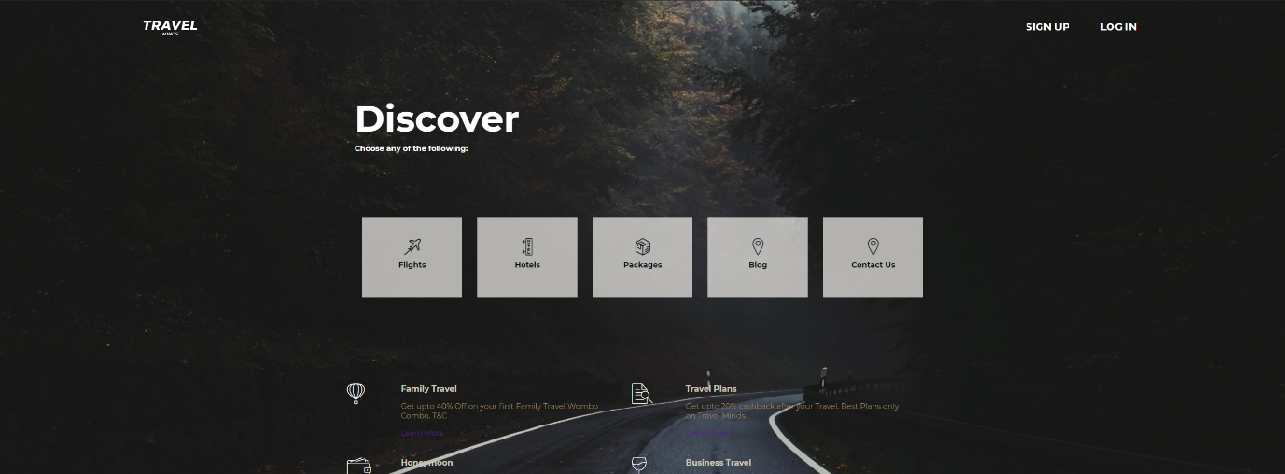

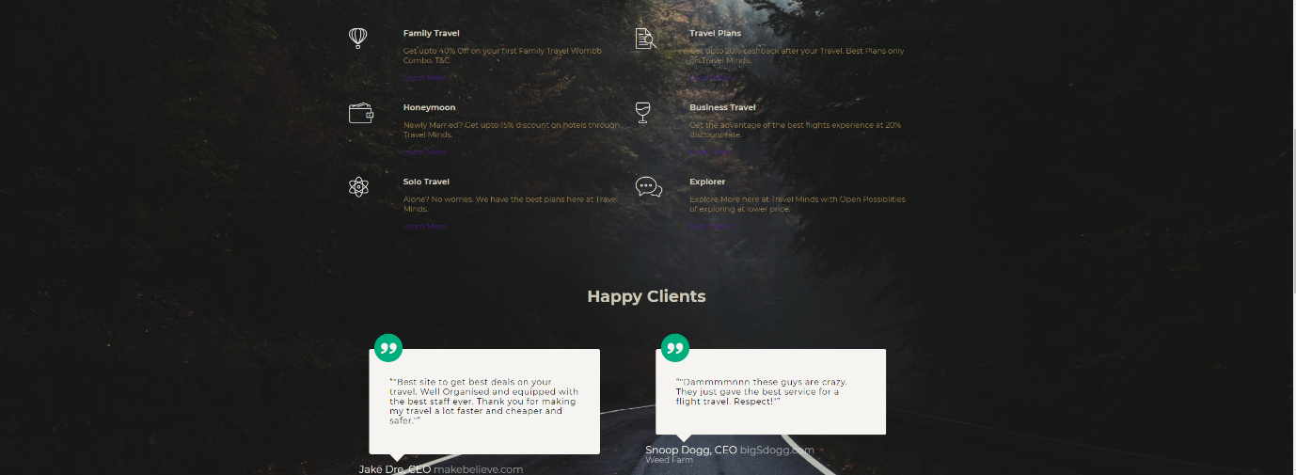

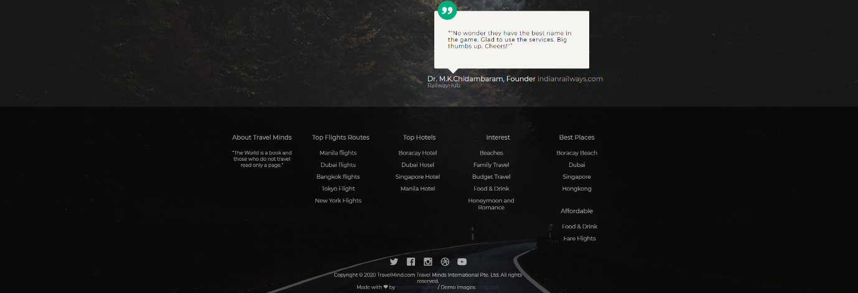

**Sign Up and Login Page Code**:

**<!DOCTYPE html>**

**<html>**

**<head>**

**<meta charset="utf-8">**

**<meta name="viewport" content="width=device-width">**

**<meta name="description" content="Travel Websites">**

**<meta name="keywords" content="web design, travel, tourism">**

**<meta name="author" content="Travel Minds">**

**<title>SignUp and Login | Travel Minds</title>**

**<link rel="stylesheet" type="text/css" href="./css/signupstyle.css">**

**<link rel="stylesheet" href="https://cdnjs.cloudflare.com/ajax/libs/font-awesome/4.7.0/css/font-awesome.min.css">**

**</head>**

**<body>**

**<header>**

**<div id="branding">**

**<a class="branding" href="Home.html"><img src="Logo.png" alt=""></a>**

**</div>**

**<nav>**

**<ul id="buttons">**

**<li class="SignUp"><a href="SignUp and LogIn.html">Sign Up</a></li>**

**<li class="LogIn"><a href="SignUp and LogIn.html">Log In</a></li>**

**</ul>**

**</nav>**

**</header>**

**<div class="container" id="container">**

**<div class="form-container sign-up-container">**

**<form action="./php/signup.php">**

**<h1>Create Account</h1>**

**<div class="social-container">**

**<a href="#" class="social"><i class="fa fa-facebook"></i></a>**

**<a href="#" class="social"><i class="fa fa-google"></i></a>**

**</div>**

**<span>or use your email for registration</span>**

**<input type="text" name="name" placeholder="Name">**

**<input type="email" name="email" placeholder="Email">**

**<input type="password" name="password" placeholder="Password">**

**<button>SignUp</button>**

**</form>**

**</div>**

**<div class="form-container sign-in-container">**

**<form action="./php/signin.php">**

**<h1>Sign In</h1>**

**<div class="social-container">**

**<a href="#" class="social"><i class="fa fa-facebook"></i></a>**

**<a href="#" class="social"><i class="fa fa-google"></i></a>**

**</div>**

**<span>or use your account</span>**

**<input type="email" name="email" placeholder="Email">**

**<input type="password" name="password" placeholder="Password">**

**<a href="#">Forgot Your Password</a>**

**<button>Sign In</button>**

**</form>**

**</div>**

**<div class="overlay-container">**

**<div class="overlay">**

**<div class="overlay-panel overlay-left">**

**<h1>Welcome Back!</h1>**

**<p>To keep connected with us please login with your personal info</p>**

**<button class="ghost" id="signIn">Sign In</button>**

**</div>**

**<div class="overlay-panel overlay-right">**

**<h1>Hello, Traveller!</h1>**

**<p>Enter your details and start journey with us</p>**

**<button class="ghost" id="signUp">Sign Up</button>**

**</div>**

**</div>**

**</div>**

**</div>**

**<footer>**

**<p>Copyright © 2020 TravelMind.com Travel Minds International Pte. Ltd. All rights reserved.</p>**

**</footer>**

**<script type="text/javascript">**

**const signUpButton = document.getElementById('signUp');**

**const signInButton = document.getElementById('signIn');**

**const container = document.getElementById('container');**

**signUpButton.addEventListener('click', () => {**

**container.classList.add("right-panel-active");**

**});**

**signInButton.addEventListener('click', () => {**

**container.classList.remove("right-panel-active");**

**});**

**</script>**

**</body>**

**</html>**

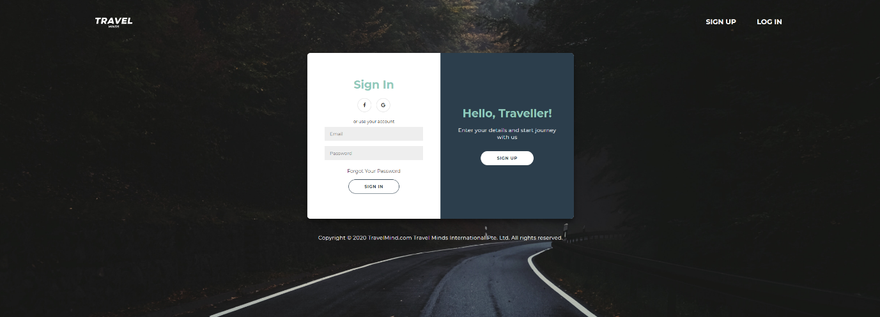

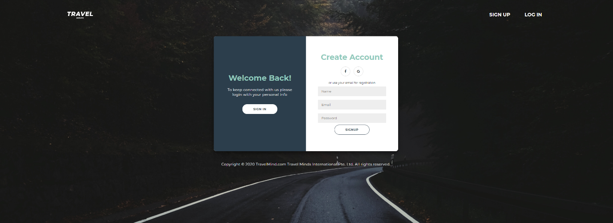

**Snapshots of Website:**

1. **Home Page**



1. Sign Up and Login Page





1. Packages Page

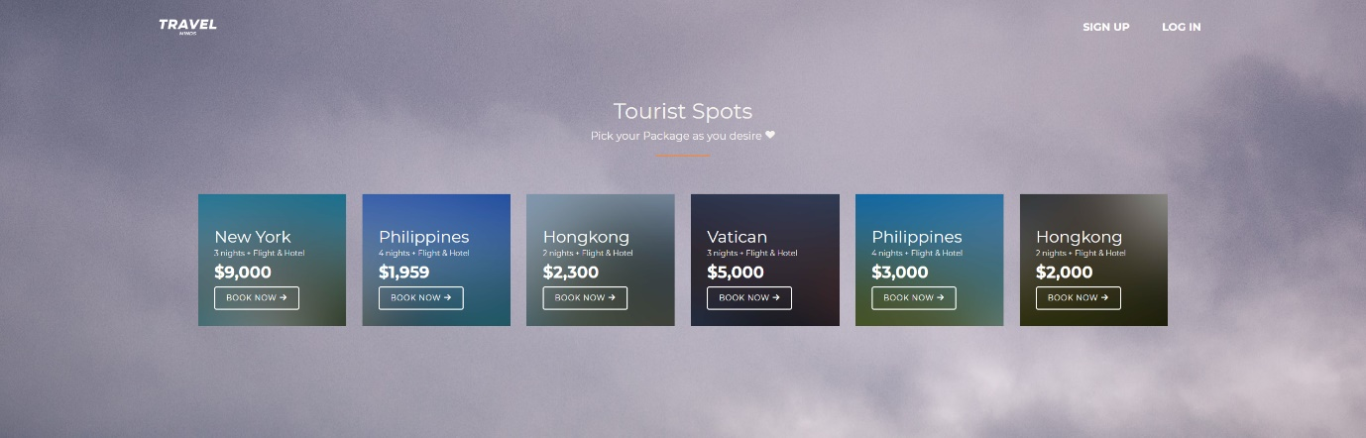

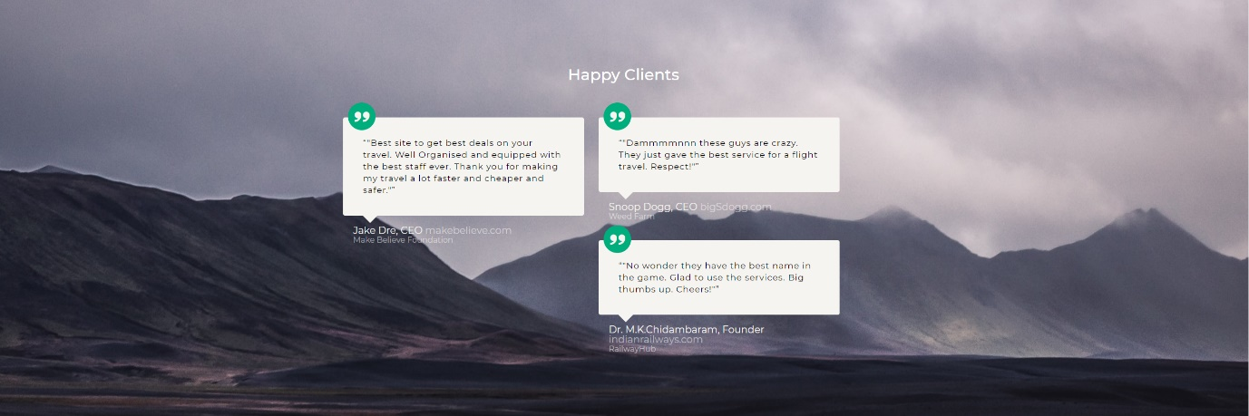

1. Blog Page

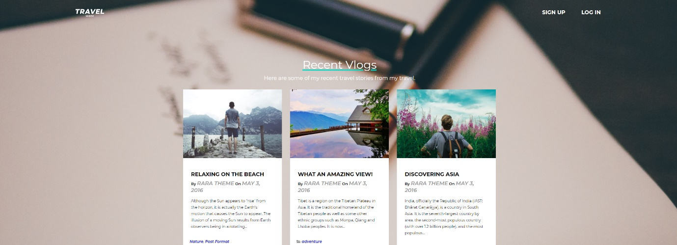

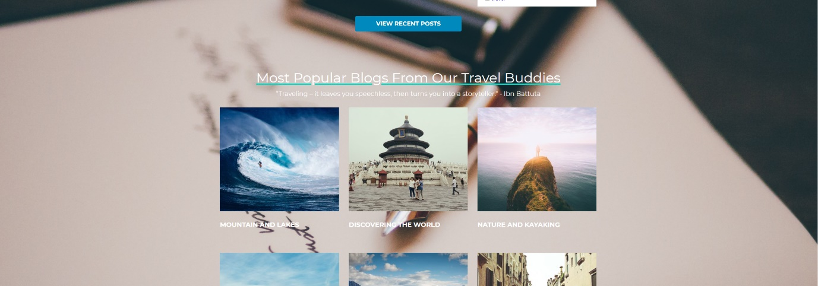

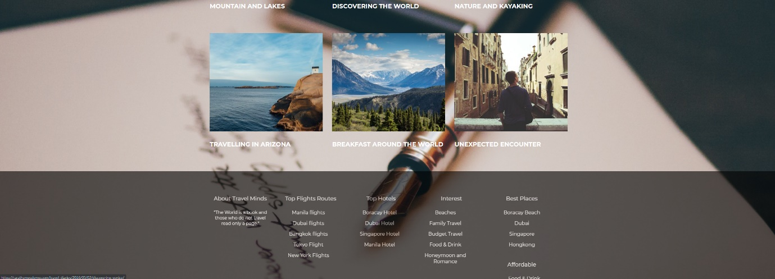

1. Contact Us Page:

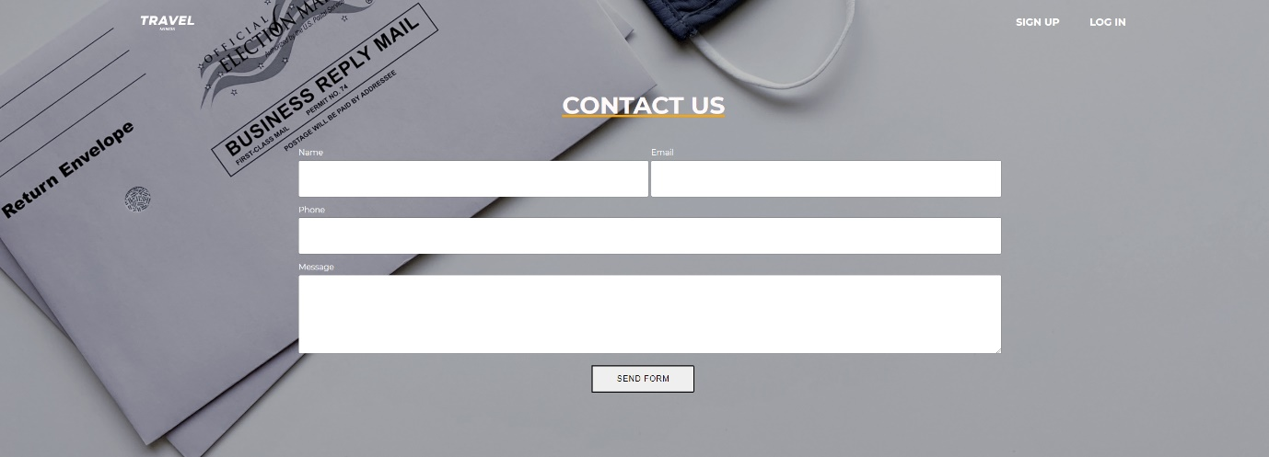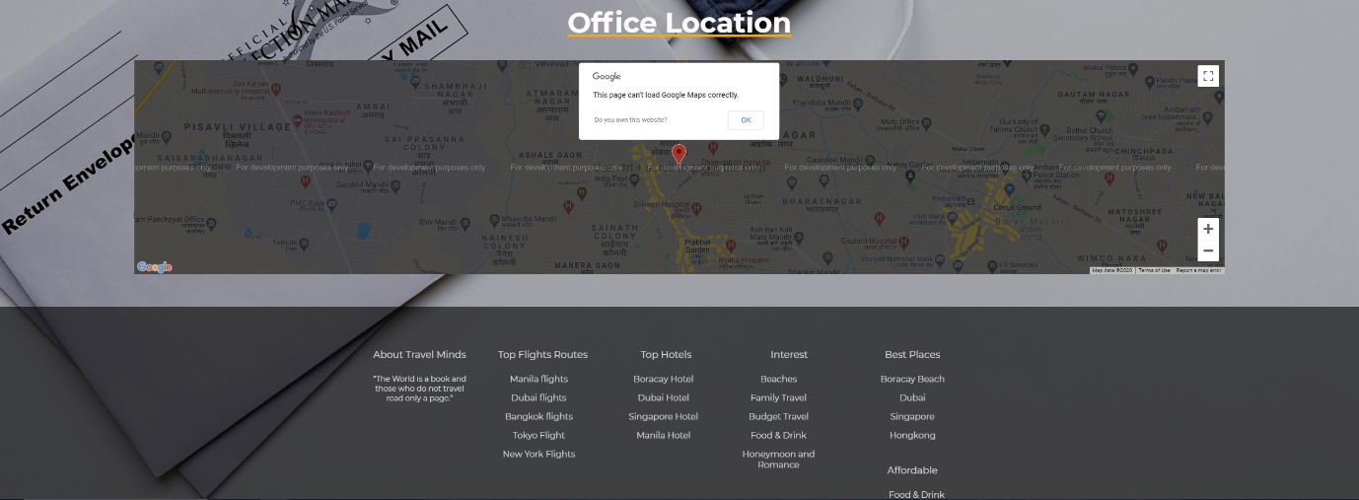

**CHAPTER 6**

**Conclusion**

**6.1 Conclusion:**

1.  **Travel** and tourism management simplifies the management process in **travelling**.

2. Fast processing and immediate results with high security.

3. Minimizing human effort and cost-efficient databases and also Navigation through the site is easy.

4. No travel agents are required which means we don’t have to pay the extra money just by using this website.

5. Provide a high standard of services suitable for individuals seeking relaxing, comfortable and memorable experiences in the hospitality and tourism industry.

**6.2 Limitations:**

* Online travel agents can charge commission on every sale. This can range between 10-20 per cent of the gross cost.
* There may be restrictive terms and conditions imposed by OTAs such as guest cancellation and automatic room reselling policies.
* You may need to find a way of managing room availability across a range of OTAs, your own website, front desk and telephone sales. This can be time consuming and labour intensive. There are software options to help you manage this.
* Using OTAs does not reduce the need to have your own website with booking engine.
* You may still need to invest in a balanced multi-channel marketing strategy.

**6.3 Future Scope:**

* + - We can give more advance software for Travel Website System including more facilities.
    - We will host the platform on online servers to make it accessible worldwide.
    - Integrate multiple load balancers to distribute loads of the system.
    - Create the master and slave database structure to reduce the overload of the database queries.

**Bibliography:**

www.wikipedia.com

[www.slideshare.net](http://www.slideshare.net)

[www.w3schools.com](http://www.w3schools.com)

[www.tutorialspoint.com](http://www.tutorialspoint.com)

[www.youtube.com/jpweb](http://www.youtube.com/jpweb)

www,github.com

www.unsplah.com